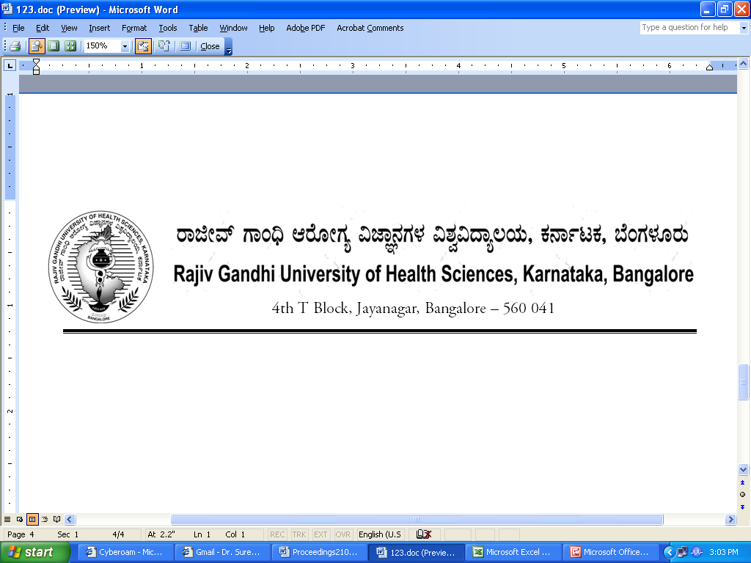
Reg(E)Exam/SPL/July- 2018 Date: 17/04/2018

Advance Notification

Sub: | Conduct of Super Specialty Course Examination during July - 2018.
********

The Super Specialty course Examination for the below mentioned courses will tentatively commence from 17th JULY- 2018. The detailed Time Table will be notified in due course.

1. | Super specialty | 17th July, 2018

The Principals of the concerned Colleges are requested to notify this on the Notice Board of their colleges for information of the students concerned.

Sd/-

Registrar (Evaluation)
To:
All the Principals of the colleges concerned for information and needful action.

Copy to:

- PA to Vice-Chancellor/Registrar/Finance Officer, RGUHS, Bangalore.
- Deputy Registrar (Admn) section for information and needful action.
- All the officers of the RGUHS, Bangalore.
- Asst. Registrar, Regional Center, Belgaum / Gulbarga.
- Guard File.

